Pokemon_search

Product Writeup

Roseline Ayitey

Full Stack developer

Prepared for

Simplilearn FSD Programme

## Introduction

This document provides details on requirements, product’s capabilities, appearance, user interactions.

In this application, a user can search for different pokemons and has the following functionalities:

* A list of pokemon details should be provided in the form of JSON data i.e., it has name, image, CP, attack, defense type of a pokemon
* It should have a search bar so that user can search the pokemon based on the name of pokemon.
* Pagination should be applied so that a user can only see 10 pokemon at a time.
* This document provides details on product’s capabilities, appearance, user interactions.

## Purpose

The purpose of this document is to capture the product details below.

* Product’s capabilities, appearance, and user interactions
* Project and developer details
* Core concepts used in the project
* Links to the GitHub repository to verify the project completion

## Product Capabilities

The product is a backend administrative portal for an ecommerce shop that provides the options to administrators to perform the below activities

* Pokemon details is retrieved from the Pokemon Restful API be provided in the form of JSON data i.e., it should have name, image, CP, attack, defense type etc.
* It has a search bar so that user can search the pokemon based on the name of pokemon.
* Pagination is applied so that a user can only see 10 pokemon at a time.

### User Interfaces

**GUI**  
As this is a web application, user interaction is via GUI.

**APPLICATION FLOW**

Step1 - Application starts by showing a pokemons displayed on the screen

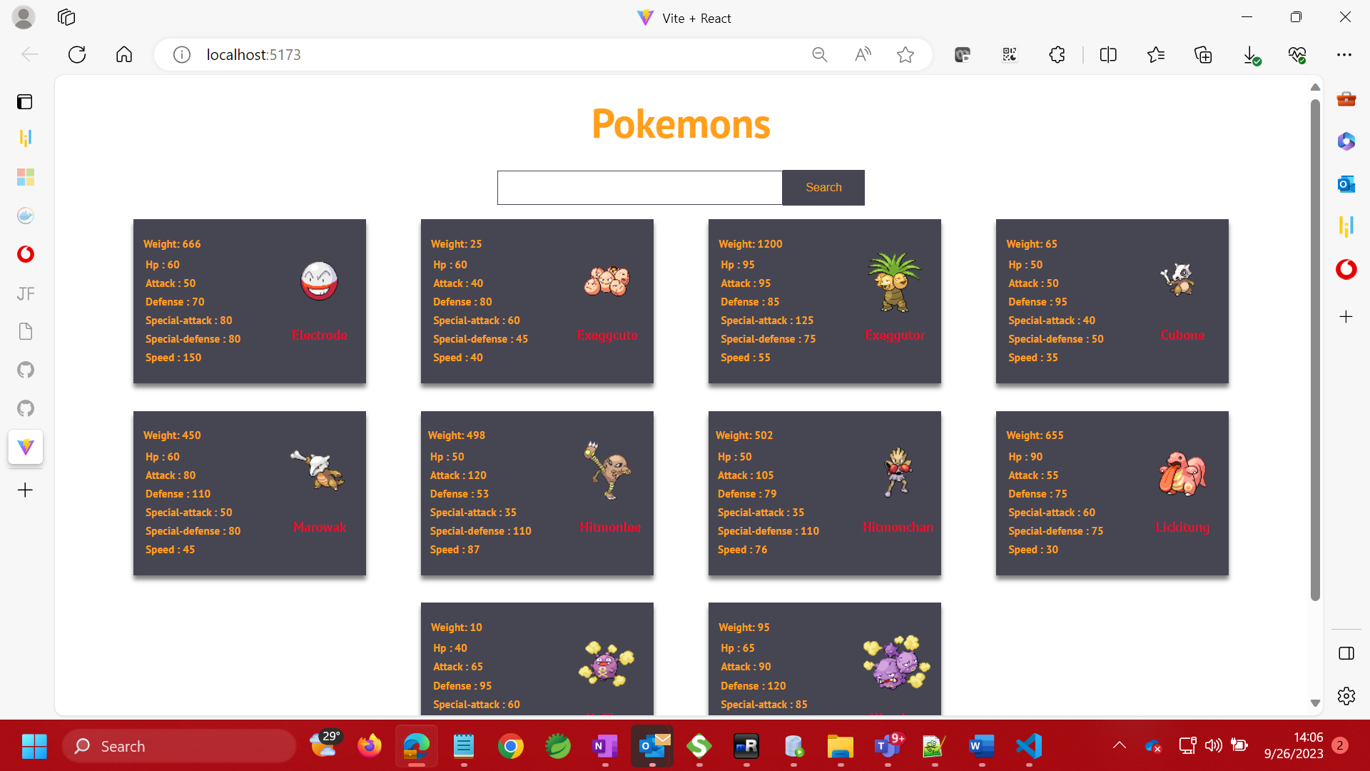

Step 2: Validate pagination

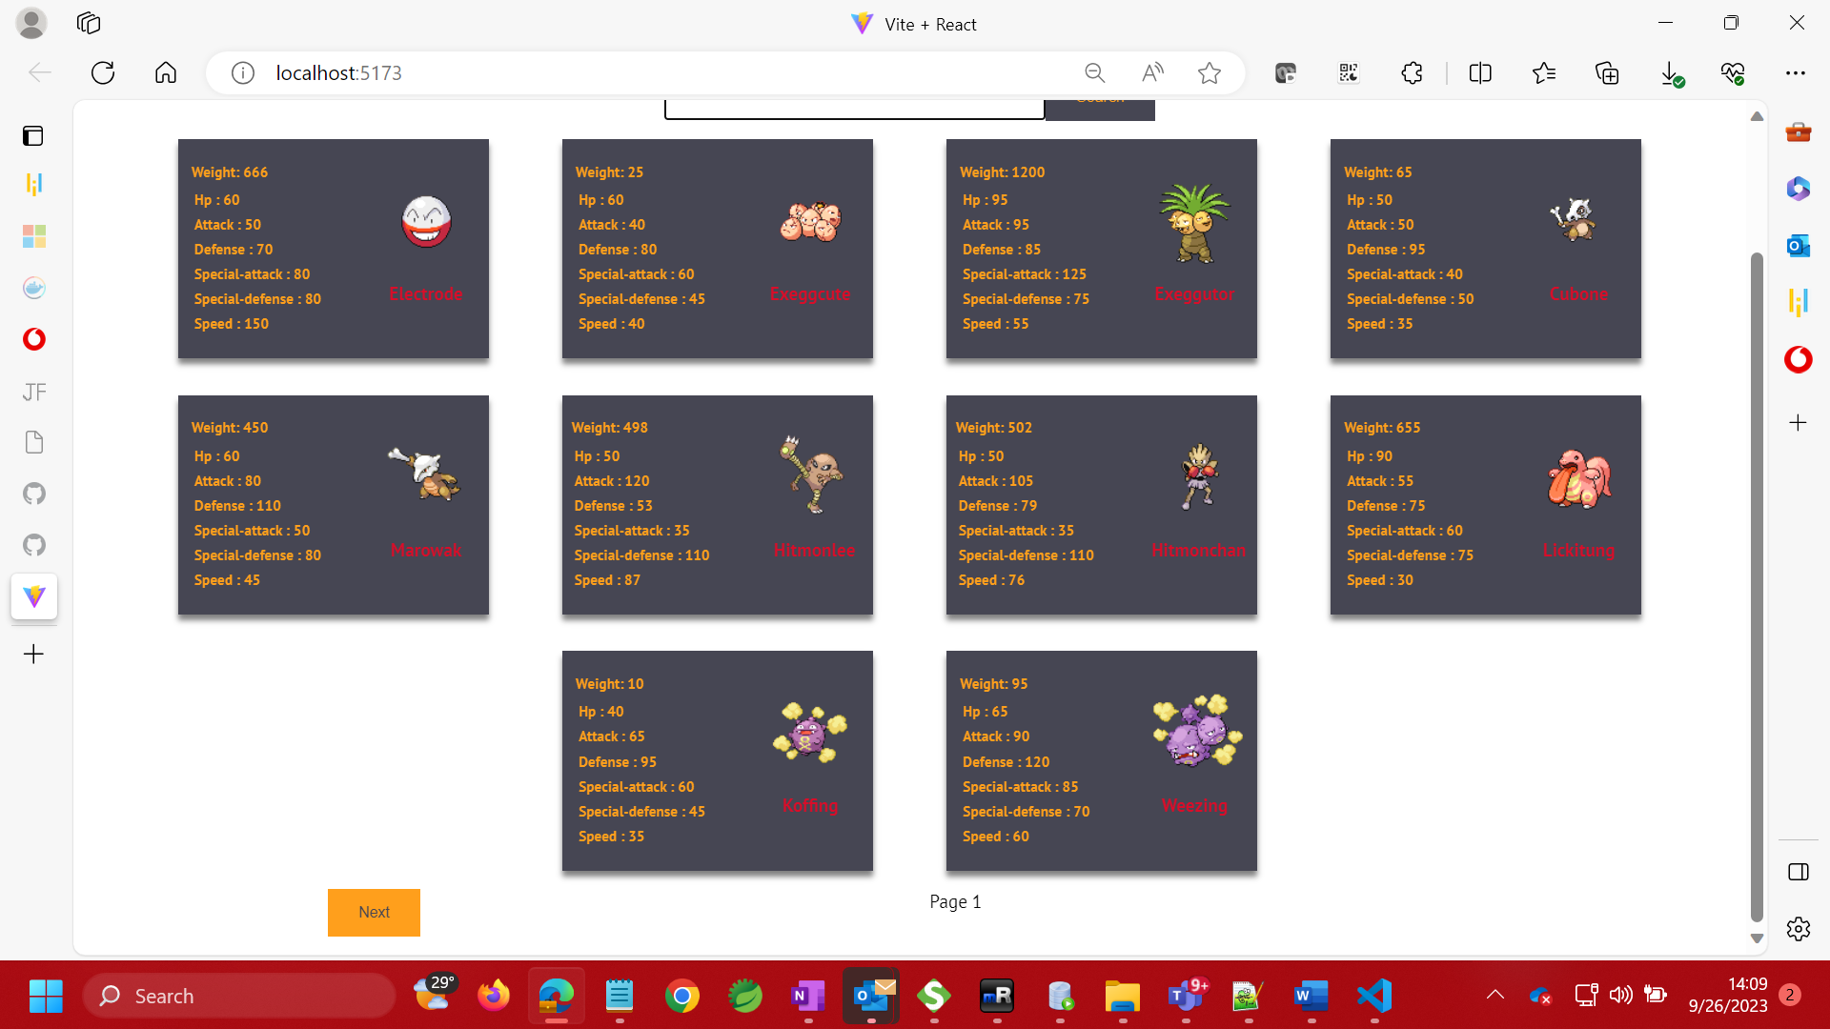

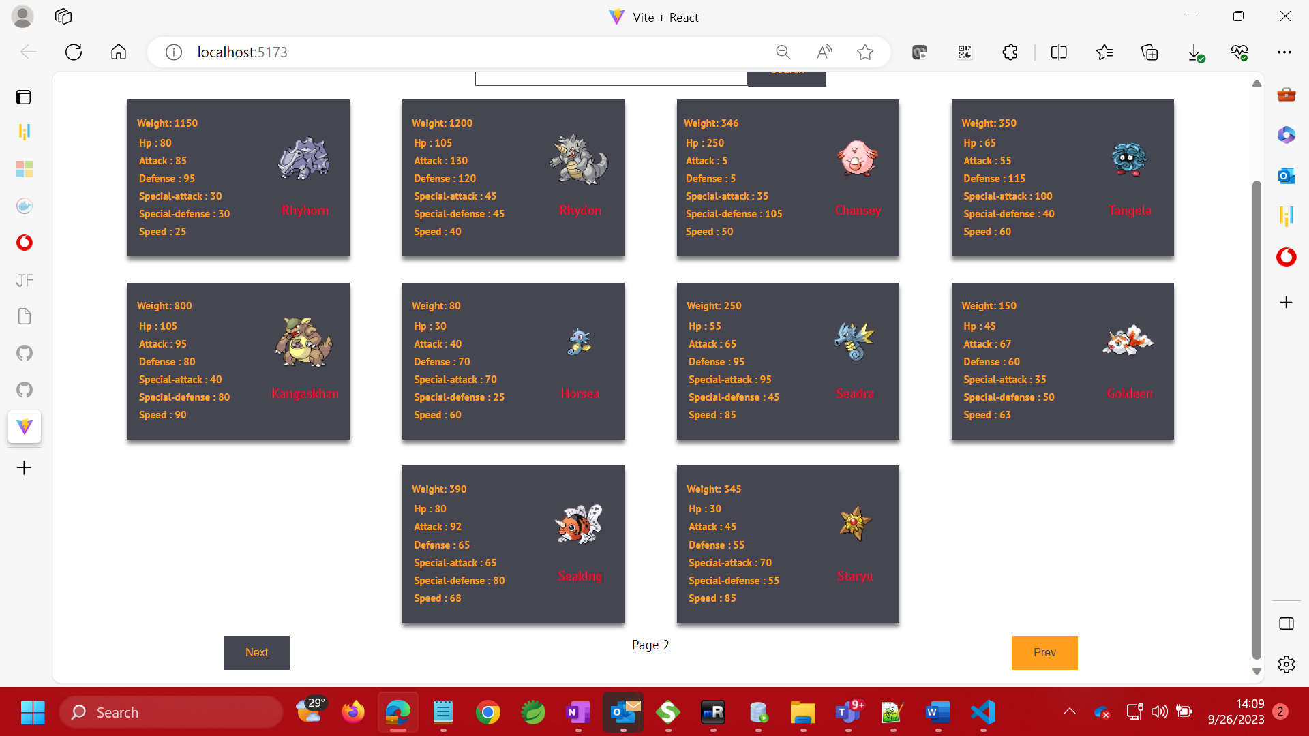

Step 3: Take user input and search for the pokemon

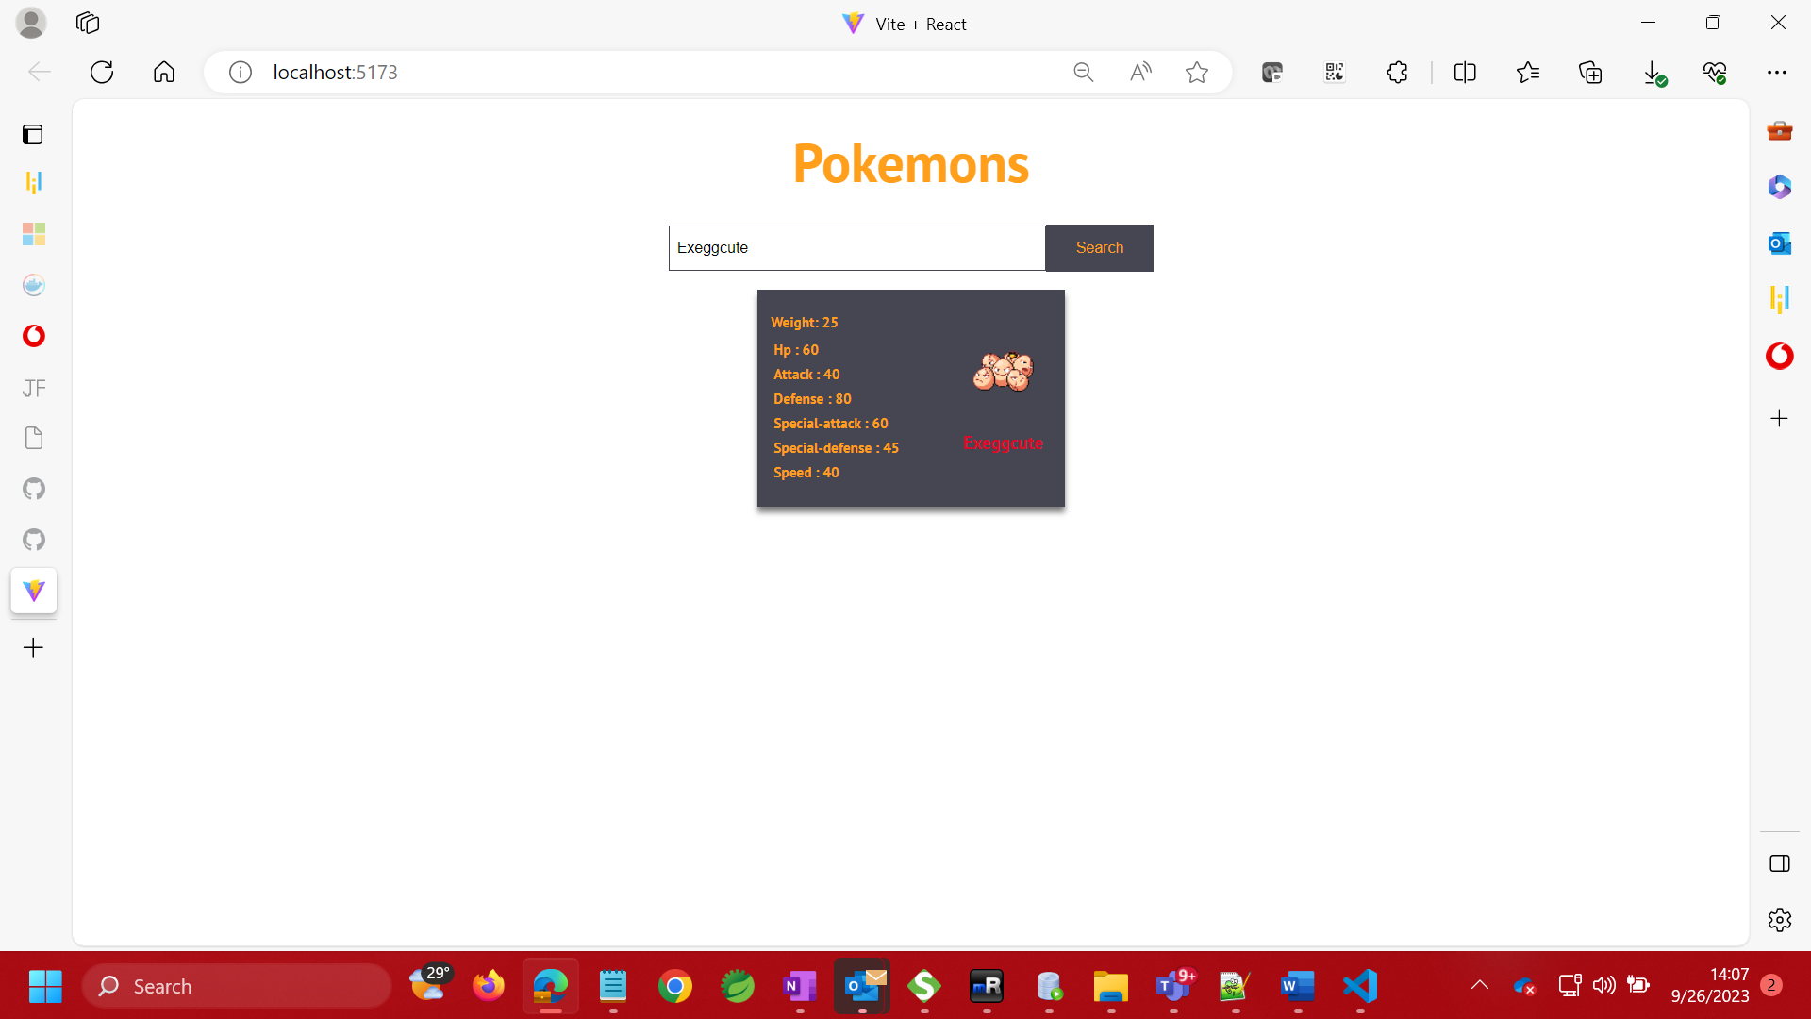

**CORE CONCEPTS AND ALGORITHYMS USED**

* HTML
* CSS
* Reactjs
* Javascript
* Vite

Link to the GitHub repository

https://github.com/roselinemills/pokemon_search

**CONCLUSION**

The project is designed to be intuitive, easy to use and deliver high-end quality experience to the user